Curriculum Vitae
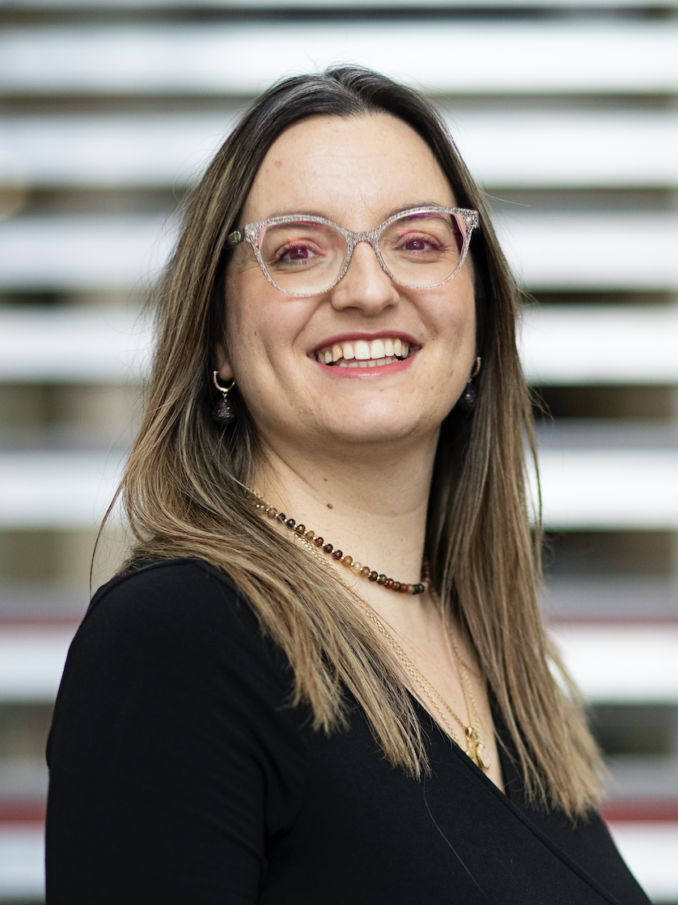

Personal Information:

Name/Surname: Christina Malamateniou, PhD (ICL) DIC (ICL) MA Clinical Education (KCL) MAcadMed (UK) SFHEA (UK) BSc (Hons) (TEI Athens)
E-mail address: christina.malamateniou@city.ac.uk, christina.malamateniou@kcl.ac.uk,
Telephone: 0044-7974715364

Current employment:
-January 2019 onwards- Postgraduate Programme Director in Radiography (MRI/CT), City, University of London, School of Health Sciences (0.6 FTE)
-March 2022 onwards-Visiting Professor, HESAV , Switzerland (0.2FTE)
Academic Education:

September 2016-September 2019: Masters in Clinical Education, King’s College London (Dissertation Subject: FoRRM, a Radiography Research Mentoring Scheme for increasing radiography research capacity)
October 2003-October 2007: PhD Research in Perinatal MR Imaging at the Robert Steiner MRI Unit, Imaging Sciences Department, Hammersmith Hospital Campus, Imperial College London.
October 2003-October 2007: Diploma of Imperial College (DIC) in Magnetic Resonance Imaging, Robert Steiner MRI Unit, Imaging Sciences Department, Hammersmith Hospital Campus, Imperial College London.
October 1998-October 2002: BSc (Hons) in Diagnostic Radiography from the Technological Educational Institute of Athens with an overall grade of 9.43/10 (First Class Honours degree with distinction equivalent, graduated as a valedictorian).

Research Grants obtained:

£25,000 towards Doctoral studentship for Mrs Emily Skelton. Funded by the RSF, City, University of London.
£15,000 “FoRRM: A Formal Radiography Research Mentoring scheme to increase research capacity”(2019-2021). Funded by the Society and College of radiographers, PI Dr Christina Malamateniou.
£13,618 CORIPS grants (2019-2020), Society and College of Radiographers, on “Understanding the needs of patients with autism spectrum disorders (ASD) who have been referred for or have undergone an MRI scan”, PI Dr Christina Malamateniou.
£9.881 REF grants (2016-2018), Faculty of Education and Health, University of Greenwich, Evaluation of a Developmental dance movement intervention for children with Autism Spectrum Disorders, PI Dr Christina Malamateniou
£14,950 “FoRRM: A Formal Radiography Research Mentoring scheme to increase research capacity”(2016-2018). Funded by the Society and College of radiographers, PI Dr Christina Malamateniou and Dr Karen Knapp.
£4,881 Designing and validating a user-led, dedicated evaluation tool to assess the impact of music therapy in children with autism spectrum disorders (ASD): a multi-agency approach (2017-2018) Funded by the Institute of Integrated Care, University of Greenwich PI Dr Christina Malamateniou
$3,229,581 Structure and function of the placenta from implantation to delivery: a next generation MRI approach ((2016-2019) funded by the National Institutes of Health, USA, (NIH application ID 9076542), PI: Professor Mary Rutherford, Co-I Dr C Malamateniou (and a consortium of another 10 Co-Is across the United kingdom and USA)
£8,340,000 i-FIND project (2014-2021) awarded by the Wellcome Trust and EPSRC to optimize fetal ultrasound screening based on high quality MRI data atlases. (named key competencies contributor, PIs Prof. Jo Hajnal, Prof. Reza Razavi).
£132,000 (2010-2012) awarded by the BRC-AHSC for the development and optimization of fetal and neonatal brain MRI protocols (PI Prof Mary Rutherford, Co-I Dr Christina Malamateniou, Prof Jo Hajnal).
£2,000 (2007) awarded by the University of Liverpool, pump priming award for establishing a research liaison between the academic department of medical imaging and the Royal Liverpool Children’s Hospital (PI Christina Malamateniou)
€65,000 (2003-2007) awarded by the Greek State Scholarships Foundation (IKY) for the completion of my doctoral research (research fellowship)

Research projects and ongoing collaborations
-Collaboration with different academics at King’s College London and Imperial College London on “Fetal MRI techniques and clinical applications” (with Professor Mary Rutherford, Professor Jo Hajnal, Professor Ralf Sinkus and others)

-Collaboration with the University of Oxford on a project studying the anatomy and architecture of cerebral vasculature of adults born preterm using MR Angiography at 3.0 Tesla (collaborators: Professor P. Leeson, Dr W.Williamson, Dr A. Lewandowski, Dr H. Boardman, University of Oxford, John Radcliffe Hospital)

- Collaboration with the Society and College of Radiographers (SCOR) in the UK for the launch of Formal Radiography Research Mentorship (FoRRM) scheme to advance radiography research involvement and support the production of measurable research outputs (collaborators: Dr Karen Knapp (Exeter), Dr Fiona Mellor (Portsmouth), Dr Helen McNair (Royal Marsden), Dr Rob Appleyard (Sheffield Hallam), Dr Rachel Harris, SCOR ),. This is an initiative whose framework I developed as part of my master’s dissertation in collaboration with King’s Learning Institute (Dr Gabriel Reedy, Mrs Sharon Markless) and University of York (Dr Neil Lunt).

Invited talks and keynote lectures (2019-2020)

- UKRC, invited lecture on radiography research mentoring schemes, Liverpool, June 2020
- ECR, Two keynote lectures on” Improving MRI practice and The importance of patient positioning for MRI”, March 2020, Vienna, Austria
- Odense University of Radiography, Denmark, November 2019: “Design, implementation and evaluation of a Formal radiography research mentoring scheme: is it fit for PhD students”?
- London Region Study Day, organised by the Society and College of Radiographers, London, UK, November 2019: “Artificial Intelligence in fetal MRI: implications for practice”
- The Annual Radiology Meeting, Dubai, UAE, October 2019: Evaluation of a Formal radiography Research mentoring Scheme in the UK: lessons learned
- EANM Barcelona, Spain, October 2019: “Research methods for Radiographers: how to prepare a successful scientific abstract”
- UKIO Liverpool, UK June 2019: “Incidental Findings in neonatal MRI scans-a radiographer’s perspective”
- ECR 2019, Vienna, Austria, March 2019 : “How to plan and structure a successful scientific research poster?”
- Presentation to EFRS Board , CEO and Educational Wing of the final evaluation of the FoRRM scheme (ECR 2019, EFRS Board, Vienna)

Awards and Distinctions (2016-onwards):

- 2019: Awarded full membership of the Academy of Medical Educators (MAcadMeD)
- 2019: Co-lead for the European Federation of Radiographer Societies MRSO working group
- 2019: City University School of Health Sciences award for excellence in the student experience
- 2018: Awarded Senior Fellowship of the Higher Education Academy
- 2017: Senior Associate of the Royal Society of Medicine
- 2016: Nominated Lead for Medical Imaging Committee of Expert Radiographers, EFRS
- 2016: Chairperson of 2016 ECR radiographer scientific programme committee (leading the scientific programme in the stream of Radiographers, increased participation across Europe by more than 20% and introduced the initiative of research mentoring scheme formally in the UK)
- 2016: Scientific Programme committee: 9th national radiographer Conference, Ioannina, Greece

Most recent REFable Journal publications

- Rainey C, O'Regan T, Matthew J, Skelton E, Woznitza N, Chu KY, Goodman S, McConnell J, Hughes C, Bond R, McFadden S, Malamateniou C. Beauty Is in the AI of the Beholder: Are We Ready for the Clinical Integration of Artificial Intelligence in Radiography? An Exploratory Analysis of Perceived AI Knowledge, Skills, Confidence, and Education Perspectives of UK Radiographers. Front Digit Health. 2021 Nov 11;3:739327. doi: 10.3389/fdgth.2021.739327
- Stogiannos N, Carlier S, Harvey-Lloyd JM, Brammer A, Nugent B, Cleaver K, McNulty JP, Dos Reis CS, Malamateniou C. A systematic review of person-centred adjustments to facilitate magnetic resonance imaging for autistic patients without the use of sedation or anaesthesia. Autism. 2022 May;26(4):782-797. doi: 10.1177/13623613211065542. Epub 2021 Dec 28.
- Stogiannos N, Harvey-Lloyd JM, Nugent B, Brammer A, Carlier S, Cleaver K, McNulty JP, Sá Dos Reis C, Malamateniou C. Autism-friendly MRI: Improving radiography practice in the UK, a survey of radiographer practitioners. Radiography (Lond). 2022 Feb;28(1):133-141. doi: 10.1016/j.radi.2021.09.003. Epub 2021 Sep 24.
- Malamateniou C, McFadden S, McQuinlan Y, England A, Woznitza N, Goldsworthy S, Currie C, Skelton E, Chu KY, Alware N, Matthews P, Hawkesford R, Tucker R, Town W, Matthew J, Kalinka C, O'Regan T. Artificial Intelligence: Guidance for clinical imaging and therapeutic radiography professionals, a summary by the Society of Radiographers AI working group. Radiography (Lond). 2021 Nov;27(4):1192-1202. doi: 10.1016/j.radi.2021.07.028. Epub 2021 Aug 20.
- Malamateniou C, Knapp KM, Pergola M, Woznitza N, Hardy M. Artificial intelligence in radiography: Where are we now and what does the future hold? Radiography (Lond). 2021 Oct;27 Suppl 1:S58-S62. doi: 10.1016/j.radi.2021.07.015. Epub 2021 Aug 8.
- Skelton E, Drey N, Rutherford M, Ayers S, Malamateniou C. Electronic consenting for conducting research remotely: A review of current practice and key recommendations for using e-consenting. Int J Med Inform. 2020 Nov;143:104271. doi: 10.1016/j.ijmedinf.2020.104271. Epub 2020 Sep 13.
- Bougias H, Georgiadou E, Malamateniou C, Stogiannos N. Identifying cardiomegaly in chest X-rays: a cross-sectional study of evaluation and comparison between different transfer learning methods. Acta Radiol. 2021 Dec;62(12):1601-1609. doi: 10.1177/0284185120973630. Epub 2020 Nov 17.

