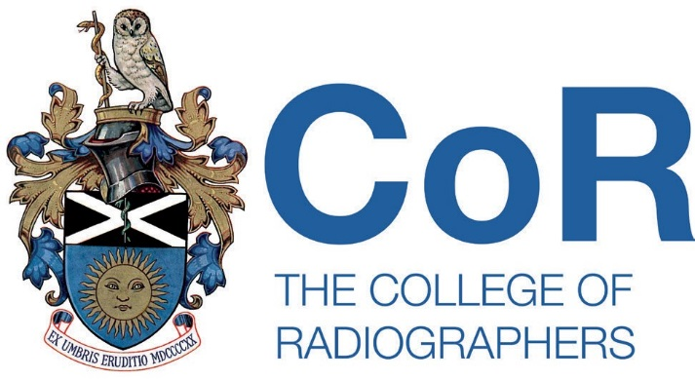

Please ensure that you are familiar with the information and caveats contained on the Log of live member research web page prior to completing this form.

Please provide the following information:

- Dates that the research project will be live.

From: 17/06/2026. To: 01/07/2026.

- Name and contact details of SoR member.

Name: Ezemba Chukwuebuka Walter
Email: mbaebuka@yahoo.com

- Information to be displayed on the Log of live member research web page:
My study is titled:
“Factors Affecting Sonographers' Compliance with Imaging Protocols in the United Kingdom: A Quantitative Study.”
The study aims to examine how individual factors (such as training, experience, and knowledge), organisational factors (including workload, time pressure, and supervision), and occupational factors (such as stress and burnout) influence sonographers’ adherence to established imaging protocols. The findings are expected to contribute to improving diagnostic quality, patient safety, and service delivery within UK ultrasound practice.

Participant requirements
I am seeking participants who meet the following criteria:
- HCPC-registered sonographers currently practising in the United Kingdom
- Minimum of one year of clinical ultrasound experience
- Actively involved in performing diagnostic ultrasound examinations
Participation involves completing an anonymous online questionnaire, which takes approximately 10–15 minutes.
The link to the questionnaire: https://docs.google.com/forms/d/e/1FAIpQLSeHi2qBSqj2E3fcReQk5mSrP5_ZLlHs3o06N9-Z6R3CT7wyXA/viewform

Return of completed form

Please return the completed form to Dr Emma Hyde via EmmaH@sor.org

