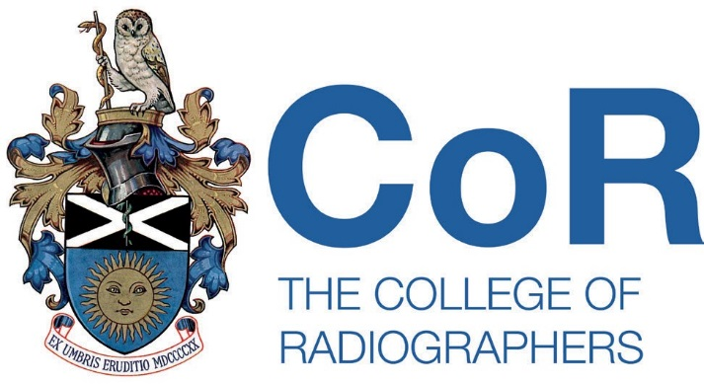

Please ensure that you are familiar with the information and caveats contained on the Log of live member research web page prior to completing this form.

Please provide the following information:

- Dates that the research project will be live.

From: 17/07/2026 To: 04/10/2026

- Name and contact details of SoR member.

Name: Dr Olanrewaju Lawal Email: olanrewaju.lawal@hsu.ac.uk

- Information to be displayed on the Log of live member research web page:

Title: Heat Wave Preparedness in UK Radiology Departments

We are conducting a national research study to explore how prepared radiology departments across the United Kingdom are for periods of extreme heat.

Who can take part? Diagnostic Radiographers, Therapeutic Radiographers, Sonographers, Radiologists, Radiology Managers, Medical Physicists, PACS Managers, Assistant Practitioners and other professionals involved in radiology service delivery currently working in UK radiology.

Participation involves completing an anonymous online questionnaire, taking approximately 5-10 minutes. No identifiable personal or organisational information will be collected.

Survey link: https://app.onlinesurveys.jisc.ac.uk/s/aeccuc/heat-wave-preparedness-in-uk-radiology-departments-a-national-1

Research QR code: 

For further information, please contact Dr Olanrewaju Lawal at olanrewaju.lawal@hsu.ac.uk

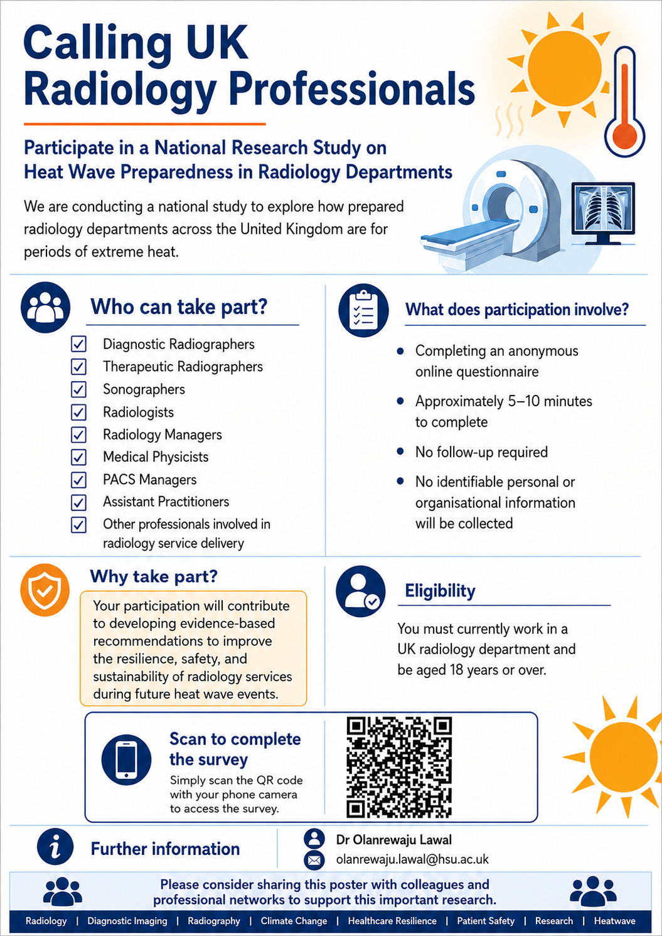

Return of completed form

Please return the completed form to Dr Emma Hyde via EmmaH@sor.org

