Title: Competency and Professional Advancement in Computed Tomography (ComPACT)
Researcher: Martine Harris
Instructions to complete e-Delphi survey, round 2

Please read these instructions carefully. Answer all questions and check that sections are complete. The survey is available at:

https://bit.ly/3rfhx8L

Previous document analysis of public and professional body frameworks has shown an abundance of non-technical competencies for radiographers. Although professionalism will feature in the final framework, consensus building in the e-Delphi is focused on context specific technical and clinical competencies for diagnostic radiographers practising in CT. These are regarded additional and complimentary to the standards expected by the Heath and Care Professions Council (HCPC).

This is round 2 questionnaire has a dual purpose:

1. To provide feedback of the responses received from the expert panel in round 1
2. To allow further opportunity to consider the statements (or practice levels) which did not gain agreement in round 1.

When you start the Delphi survey you will asked whether you think that the competency statement is essential (E), desirable (D) or not necessary (N) at different practice levels.
For statements where agreement has been gained, the information provided acts as feedback only and no action is required. Please don't untick any pre-populated boxes as it may prevent you from proceeding through the survey.
Example 1: The statement has been agreed at all practice levels as essential.

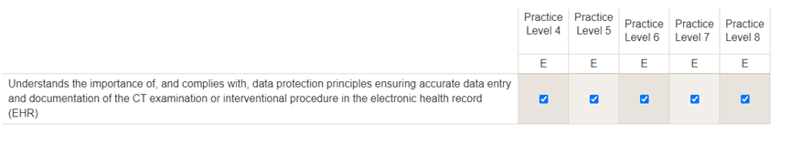

For statements where agreement has not been gained, I would like you to decide if the statement is E, D or N. Please tick only one option (box) per practice level where indicated as *required.
Please note: Based on the number of experts involved in round 1 of the survey agreement was equated with 69.0% or more. To support your decision-making percentage feedback from round 1 responses is provided.
Example 2: The statement has been agreed at practice levels 4, 6, 7 and 8 as not required, desirable and essential respectively. A response is required for practice level 5.

