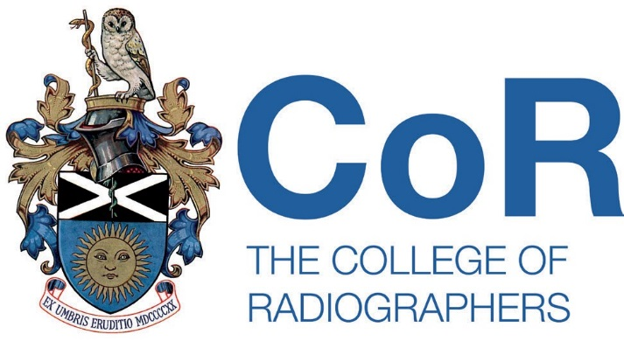

Please ensure that you are familiar with the information and caveats contained on the Log of live member research web page prior to completing this form.

Please provide the following information:

- Dates that the research project will be live.

From: 09/10/2025 To: 31/12/2026

- Name and contact details of SoR member.

Name: Teresa Amato Email: amatoteresa91@gmail.com

- Information to be displayed on the Log of live member research web page:

Exploring the role of clinical debriefing in supporting the emotional wellbeing of MRI Radiographers

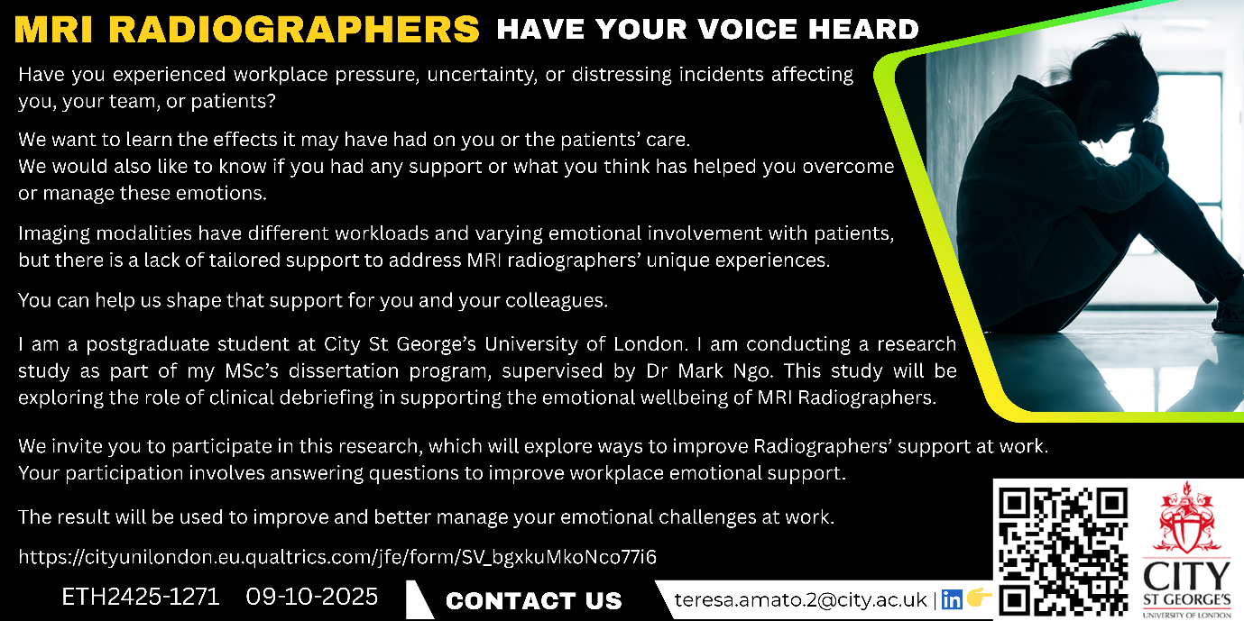

We would like to invite you to take part in a research study performed as part of Teresa's MSc and supervised by Dr Mark Ngo. Before you decide whether you would like to take part it is important that you understand why the research is being done and what it would involve for you. Please take time to read the following information carefully and discuss it with others if you wish. Ask us if there is anything that is not clear or if you would like more information. You will be given a copy of this information sheet to keep.

What is the purpose of the study?
Background MRI Radiographers frequently have prolonged contact with oncology or claustrophobic patients, which makes them greatly exposed to emotional distress because of consistently handling patient's anxiety. Clinical debriefing (CD) is a structured discussion session where participants discuss and reflect on recent experiences. CD may offer individuals the opportunity to connect, share and discuss issues in a safe space to encourage openness and honesty. There is currently limited evidence of their use in the MRI setting. Debriefing after challenging situations such as anaphylaxis, psychological stress and emotional distress associated with engaging with anxious cancer patients, violence or abuse, may be beneficial.

Aims of the study: This qualitative study aims to explore the perspectives and experiences of MRI radiographers regarding the use of clinical debriefing following challenging work situations. The researcher will ask you some open-ended questions for data collection.

Please, you can use the following link to learn more or take part: https://cityunilondon.eu.qualtrics.com/jfe/form/SV_bgxkuMkoNco77i6
If you wish to take part, kindly complete the consent form available at the link provided, then leave you email and I will get in touch to arrange an interview. Alternatively, you can also get in touch with me directly at teresa.amato.2@city.ac.uk

Return of completed form

Please return the completed form to Dr Emma Hyde via EmmaH@sor.org

