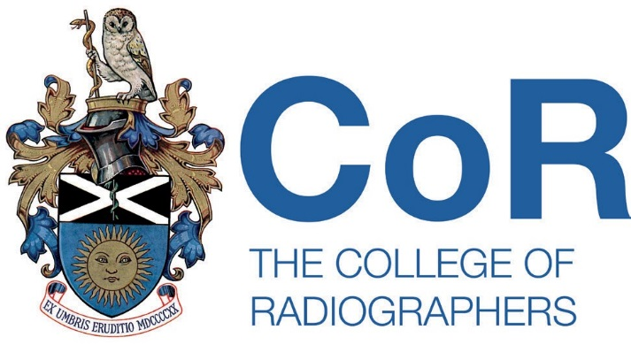

Please ensure that you are familiar with the information and caveats contained on the Log of live member research web page prior to completing this form.

Please provide the following information:

- Dates that the research project will be live.

From: 18/05/2026 To: 30/06/2027

- Name and contact details of SoR member.

Name: Ashleigh McIlroy Email: a.mcilroy@ulster.ac.uk

SoR Membership Number: 92453

- Information to be displayed on the Log of live member research web page:

Please see page below.


“An exploration of radiographers’ current training and training needs in relation to caring for patients with Autism Spectrum Disorder in the United Kingdom and Ireland”.

I am Ashleigh McIlroy, a PhD researcher at Ulster University. I have gained ethical approval for this study through Ulster University and am looking for diagnostic radiographers, therapeutic radiographers, and radiography students (undergraduate and postgraduate) to participate in this questionnaire.

This questionnaire forms part of my PhD research and aims to explore radiographers’ knowledge and understanding of autism care, any autism related training they have received, and their future training needs within radiography practice.

Your experience and perspective are highly valued and will contribute to improving, understanding and informing future training and educational needs for radiographers caring for patients with Autism Spectrum Disorder. The questionnaire will take approximately 10 minutes to complete. Thank you for considering taking part in this important research.

Please click the link below or scan the QR code provided to complete the questionnaire.

https://app.onlinesurveys.jisc.ac.uk/s/ulster/autism-stigma-and-knowledge-questionnaire-revised-version-ask-q



Return of completed form

Please return the completed form to Dr Emma Hyde via EmmaH@sor.org

