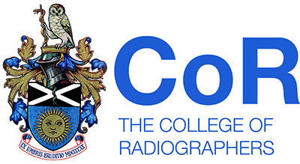
APPROVAL &
ACCREDITATION
BOARD

Criteria for inclusion on the register of Assessors

Individuals wishing to undertake the activities associated with a College of Radiographers assessor must normally provide evidence of the following criteria:

- Membership of The Society of Radiographers or another appropriate professional body
- Registration with the HCPC as a Radiographer in the UK or registration with an appropriate regulatory authority
- Awareness of professional body policies relative to radiography practice
- Agreement to accept and work within the guidelines established by the Society and College of Radiographers
- Active involvement in education and training programmes in radiography, if applying to approve educational programmes
- Awareness of national and regional differences in the organisation and delivery of education and radiography/radiotherapy services
- Specialist knowledge and/ experience in an areas(s) relevant to diagnostic imaging and radiotherapy
- For clinical representatives :
  - A minimum of 5 years clinical experience
- For academic representatives:
  - An understanding of current education policies and practice
  - A teaching qualification
  - Education to master’s degree level or equivalent
  - Experience in curriculum development (for assessors wishing to approve educational programmes)
It is expected that registered Assessors will:

- Participate in the training programmes for assessors provided by the Society and College of Radiographers
- Keep up to date with and apply professional body policies relevant to radiography practice
- Commit to maintaining, developing and enhancing their professional knowledge, skills and competence through continuing professional development. This may be evidenced by a current Certificate of Accreditation from CPD Now

Applications will be scrutinised by a panel. The Register will be subject to review every 2 years, where an assessor will be required to provide evidence of continuing professional development.

